|  |  |
| --- | --- |
| **Name** |  |
| **Reg. No** |  |
| **Marks / Grade** |  |

**EXPERIMENT # 06**

**To apply Shunt Capacitive Compensation in a Transmission lines**

**Objective:**

To learn the importance of Shunt Compensation by simulating a single phase and three phase medium length transmission line with different loads on MATLAB Simulink and PWS.

**Theory:**

During power transmission, there will be problems like poor voltage regulation and power factor, poor efficiency and less reliability shunt capacitive compensation is a method to avoid these problems by using this we could get better power factor. Most of the power systems are loaded with an inductive load to compensate the inductive load shut capacitor will be applied to the load. This type of compensation could be done to substation level or the transmission level

The advantages of shunt capacitive compensations are

• Transmission power loss is decreased by reducing reactive current

• More capacity is available to supply the power to the load

• Better regulation due to less voltage drop

• Due to less loading, the life of power system equipment increased

• It could achieve peak load demand

• There will be reduced stress for generator excitation system

• Source generator’s power factor increased

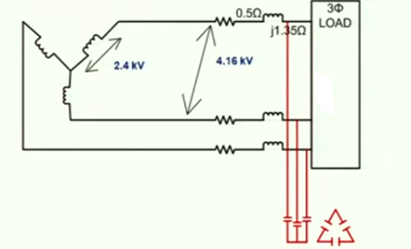

Figure 1: Three Phase Transmission lines with Shunt Capacitor

**OPERATION**

If an inductive load is connected to a transmission line the power factor lags and it is because of the lagging of the load current as a solution for this problem a shunt capacitor is connected which draws the current leading the source voltage and the result will be better power factor

Low power factor causes low voltage regulation the capacitor causes the current to lead the voltage the inductive resistance of the system will be cancelled by the capacitive reactance it will be good to use a capacitor bank instead of a single capacitor

Capacitor can’t be installed for small loads instead of that it could be connected to medium and large loads so it is difficult to connect capacitor at each load instead of that it will be connected to main distribution substation or secondary grid substation.

**Procedure:**

* Start MATLAB and go to start Simulink $>$ Simpower system $>$ Block Library.
* Open new file by clicking file new model or pressing ctrl+ n.
* Take Voltmeter and Ammeter from measurement section of Block Library.
* Take AC Voltage source from source section.
* Take RLC Load and branch, ground node, PI section line from element section.
* Also take Power GUI from block library simpower system in your file.
* Make connection as shown in figure.
* Calculate voltage regulation using formula.
* Now apply shunt capacitor at receiving end and see variation in voltage and current and their phase difference.
* Change value of capacitor and find trend variation in voltage, current and power factor.
* Repeat this system for different values of loads and capacitor values draw table and also draw graph for different values.

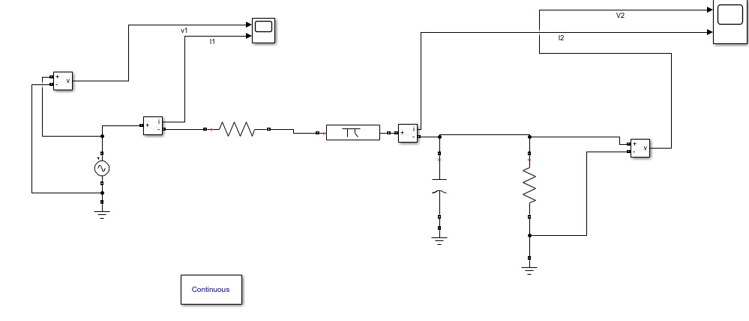

Figure 2: MATLAB setup of transmission lines

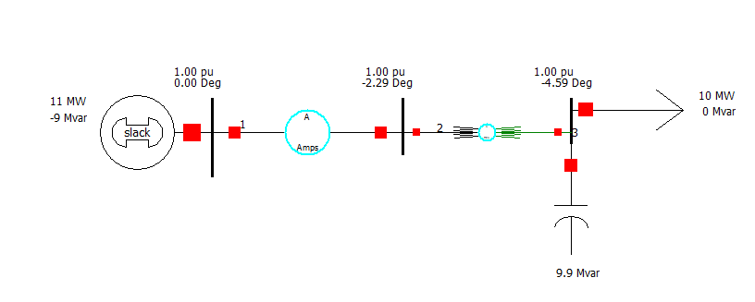

Figure 3: Transmission line setup with shunt Capacitor in PWS

**Parameters of different components:**

**AC Voltage Source:**

Voltage Peak=_______________ , Frequency:

**Series RLC Branch:**

**R**=_______ , L=_______ ,C=__________

**Series RLC Load:**

R=________ , L=________ , C=_______

Three types of loads should be simulated for each T.L model.

* Pure resistive load
* Inductive load
* Capacitive Load

**Tasks:**

* Simulation is done in single phase system and draw tables and graphs.
* Simulation is done in three phase system and draw tables and graphs.
* Simulation is performed in PWS and draw tables and graphs. See the affects by changing the transmission lines resistance and reactance alternatively.
* All above tasks are done for short and medium transmission lines.